**CHAPTER I**

**INTRODUCTION**

This chapter begins with an introduction to the problem that the project aims to solve, as well as general information about the project's objectives and goals.

**Background of the Study**

The study focuses on evaluating the usability and user experience of the ListMate prototype, an innovative app designed to streamline grocery shopping and household organization. With features such as recipe discovery, collaborative shopping list planning, offline mode, voice input, and barcode scanning, the study aims to gather user feedback on the app’s interface design, functionality, and overall user satisfaction. By employing a 5-point Likert scale in a Google Forms survey, the research seeks to understand users' ease of use, satisfaction, and any challenges encountered, thereby informing future enhancements to better meet user needs and improve the app's effectiveness in daily household management.

**Solving the Problem**

Addressing the challenges of grocery shopping and household management necessitates a comprehensive and user-centric approach. The ListMate app is meticulously designed to streamline these tasks through an intuitive interface and a suite of advanced features, including collaborative shopping lists, recipe discovery, offline access, voice input, and barcode scanning. By leveraging these functionalities, ListMate aims to enhance convenience and efficiency, making the process of planning and organizing household needs more manageable and less time-consuming.

Our approach includes systematically gathering user feedback to inform continuous improvements. By analyzing real-world usage data and user experiences, we can refine the app to better meet the needs of our users. This iterative process ensures that ListMate evolves in alignment with user expectations and preferences. Ultimately, our goal is to transform grocery shopping and household management into activities that are not only efficient but also enjoyable, thereby improving overall user satisfaction and daily living.

***Who are the potential users?***

The potential users of ListMate include a diverse range of individuals and households seeking to streamline their grocery shopping and household management tasks. This includes busy professionals who need efficient meal planning and shopping solutions, families looking to coordinate and share shopping lists, health-conscious individuals tracking nutritional information, and anyone who appreciates the convenience of voice input and barcode scanning for quick and accurate item entry. Additionally, ListMate is ideal for those who prefer offline access to their lists and recipes, ensuring functionality even without an internet connection.

***What tasks do they seek to perform?***

Potential users of ListMate seek to perform a variety of tasks aimed at simplifying and organizing their household and grocery shopping activities. These tasks include creating and managing shopping lists, discovering and saving recipes, coordinating shopping with family members or roommates, and accessing their lists and recipes offline. Users also look to add items quickly through voice input and barcode scanning, track nutritional information directly from product packaging, and plan meals efficiently. Overall, they seek a seamless, user-friendly experience that enhances convenience and reduces the time and effort spent on household management.

***What functionality should any system provide to these users?***

Any system designed for these users should offer a user-friendly interface, robust shopping list management, and recipe discovery and saving features. It should support offline access, voice input, and barcode scanning for added convenience and accessibility. Additionally, the system should provide nutritional tracking, meal planning tools, and collaboration features for coordinated household management.

***What constraints will be placed on your eventual design?***

The design of ListMate will need to accommodate various constraints, including ensuring compatibility with multiple devices and operating systems for broad user accessibility. It must also prioritize data security and privacy, adhering to relevant regulations to protect user information. Additionally, the design should balance feature richness with performance efficiency to ensure a smooth and responsive user experience.

***What criteria should be used to judge if your design is a success or not?***

The success of the ListMate design hinges on user satisfaction, measured by feedback on usability, functionality, and overall experience. Engaging users through frequent and sustained app usage will indicate its effectiveness in meeting their needs. Reliable performance across various devices and platforms, coupled with minimal technical issues, ensures a seamless user experience. Additionally, adherence to stringent data security standards and strong market adoption underscore the app's relevance and trustworthiness in the marketplace.

**Statement of the Problem**

Our project, ListMate, aims to tackle the following statements:

1. **Disorganized Shopping Lists:** Users often struggle to maintain and organize their shopping lists, leading to missed items and multiple trips to the store.
2. **Lack of Meal Planning:** Many individuals and families lack effective tools for discovering and planning meals, which can lead to unhealthy eating habits and food waste.
3. **Inefficient Collaboration:** Traditional shopping lists do not support real-time collaboration, making it difficult for multiple users to manage and update lists together.
4. **Complex Interfaces:** Existing apps for shopping and meal planning often have complex interfaces that are not user-friendly.
5. **Limited Customization:** Few applications offer personalized recommendations based on user preferences, dietary requirements, and shopping history.

**CHAPTER II**

**RESEARCH DESIGN**

The following chapter contains an analysis of the project’s requirements according to its objectives in order to map out the focus of the prototype.

**Task Analysis**

Task analysis involves breaking down complex tasks into smaller, manageable units to understand user interactions and system requirements.

**Hierarchical Task Analysis:** The team conducted HTA to visualize the interaction hierarchy within ListMate. This included identifying primary tasks such as creating shopping lists, discovering recipes, and sharing lists, and subtasks like user authentication and list item addition.

**Requirements Gathering**

Requirements gathering involves collecting and documenting the necessary information for designing the application.

**Methods Used:**

* **Surveys:** Distributed surveys to a broader audience to gather quantitative data on shopping habits, preferences for meal planning features, and concerns about grocery shopping inefficiencies.
* Interviews: Conducted interviews with potential users to understand their specific needs and challenges in household organization and shopping.

**Requirements Based on Perspectives:**

* **User Requirements:**
  + Intuitive List Management: Need for an easy-to-use interface for creating and managing shopping lists.
  + Collaborative Features: Real-time list sharing and updating capabilities for multiple users.
  + Personalized Recommendations: Smart suggestions based on user preferences, shopping history, and dietary requirements.
* **Functional Requirements:**
  + Secure Authentication: Ensure secure login and user authentication.
  + Real-Time Synchronization: Enable real-time data synchronization across multiple devices.
* **Data Requirements:**
  + User Preferences: Storage of user preferences and usage statistics.
  + Recipe Database: Access to a comprehensive database of recipes and meal ideas.
* **Environmental Requirements:**
* Minimal Resource Consumption: Ensure minimal impact on device battery life and performance.
* Usability Requirements:
* Clear Interface Design: Develop a user-friendly and intuitive interface.
* Error Prevention: Implement mechanisms to prevent and recover from errors.
* Designer Requirements:
  + Analytics Access: Provide access to app usage analytics for continuous improvement.
  + Scalability: Ensure the application is scalable for future feature enhancements.

**CHAPTER III**

**DESIGN PROCESS AND PROTOTYPING**

The following chapter illustrates the project’s design choices and summary, showcasing the evolution of the application. This chapter also contains the official prototype of the application.

**Design Space**

ListMate focuses on optimizing household organization through intuitive features designed for grocery shopping and meal planning. While location-based services operate seamlessly, the app's core functionalities emphasize user-friendly interfaces and collaborative list management. Ensuring smooth task prioritization and tracking is crucial for enhancing daily routines and overall household efficiency.

**Design Summary**

In developing ListMate, our design approach prioritizes simplicity and functionality. We aimed to create a visually clean interface that facilitates seamless navigation and task management. Our design choices emphasize user engagement and ease of use, with intuitive iconography and a cohesive color scheme. By focusing on enhancing grocery shopping and meal planning experiences, ListMate aims to streamline household management and improve daily productivity effortlessly.

**Application Icon**

**Design**

**Color Palettes**



The various color schemes with corresponding codes shown above were chosen to be used in the program. Though it has not been decided upon yet, the palette will be prepared by the time the duo gets closer to the prototyping phase.

**Storyboarding and Prototyping**

**First Image Scenario:**

Shopping in the Supermarket:

* + Top-left Panel: A user is browsing the shelves, searching for items. They are using ListMate to ensure they don't forget any items on their list.
  + Top-right Panel: At the checkout counter, the user is reviewing their purchases with the cashier. ListMate helps them quickly check off items and ensure they have everything they need.
  + Bottom-left Panel: The user is leaving the supermarket, satisfied with their efficient shopping experience. ListMate has made the process smooth and organized.

Bottom-right Panel: A promotional image highlighting the benefits of ListMate, with a friendly mascot (a cat) and a person recommending to download ListMate.

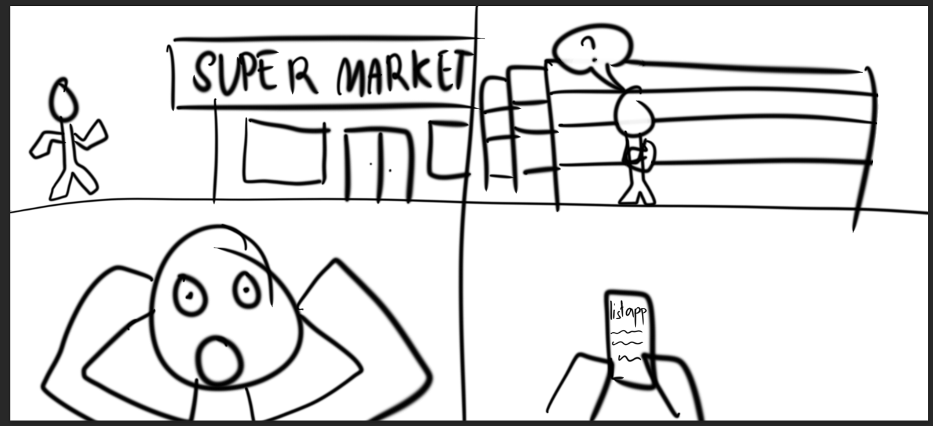

### **Second Image Scenario:**

Pre-shopping Preparation and Post-shopping Reflection:

* + **Top-left Panel**: The user is heading towards the supermarket, ready for their shopping trip. They have ListMate prepared with their shopping list.
  + **Top-right Panel**: Inside the supermarket, the user is using ListMate to navigate the aisles and find items efficiently.
  + **Bottom-left Panel**: The user is shocked or surprised, due to forgetting an important item or an unexpected event. This scenario highlights the importance of having a comprehensive shopping list.
  + **Bottom-right Panel**: The user is looking at their phone with the ListMate app open, possibly realizing they missed an item on their list. This shows the app's role in helping users stay organized and avoid such issues in future trips.

**Design Sketches**

**Prototype**

**CHAPTER IV**

**EVALUATION OF PROTOTYPING**

This chapter contains the evaluation of the prototype and the results and feedback of future users.

**Evaluation Plan**

The application’s prototype will be judged on the following questions to gauge the users’ feedback on the aesthetic and the ease of use:

**Section 1:**

1. How was the overall aesthetics and design of the application?
2. How was the ease of navigating through the app?
3. How was the ease of ordering in the app?

**Section 2:**

|  |
| --- |
| 1. User-Friendly Interface |
| 1. Shopping List Management |
| 1. Recipe Integration |
| 1. Smart Suggestions from Inspiration Tabs |
| 1. Organizational Tools |
| 1. Profile Accessibility |

**Results**

Using a small-scale, quick survey made on Google Forms, 5 potential users were asked to rate the application according to the evaluation plan. The results are as follows.

### **Participant Survey and Feedback**

#### **Results**

|  |
| --- |
| **SECTION 1** |
| |  |  |  |  | | --- | --- | --- | --- | | Question | Mean | Interpretation | Classification | | How would you evaluate your experience with the ListMate Prototype? | 5 | Acceptable | Successful | | How would you rate the UI design of the prototype? | 4.51 | Acceptable | Successful | | How easily were you able to follow the provided tasks? | 4.12 | Acceptable | Successful |   **SECTION 2** |
| | **Feature** | **Mean** | **Interpretation** | **Classification** | | --- | --- | --- | --- | | User-Friendly Interface | 4.32 | Acceptable | Successful | | Shopping List Management | 4.46 | Acceptable | Successful | | Recipe Integration | 4.01 | Moderately Acceptable | Neutral | | Smart Suggestions from Inspiration Tabs | 4.85 | Highly Acceptable | Successful | | Organizational Tools | 4.65 | Highly Acceptable | Successful | | Profile Accessibility | 4.65 | Highly Acceptable | Successful | | Average | 4.34 | Acceptable | Successful | |

**Feedback**

While most of the feedback was overwhelmingly positive, some focused on a few issues. Common issues revolved around the Recipe Integration feature of the prototype. These issues tend to raise concern that the integration was somewhat difficult to follow.

**Discussion**

The table represents the data for the survey conducted after the online testing. It shows that the prototype is at an Acceptable stage of quality and is deemed Successful. The team would still, however, like to focus on the Recipe Integration feature, which seems to have a Neutral consensus. Using the 10 Usability Heuristics Criteria, this data shows that the prototype was able to please the participants and follow the criteria with key points such as its Minimalistic Approach and Visibility.

**CHAPTER V**

**Summary**

In summary, ListMate revolutionizes grocery shopping and household management with its intuitive interface and advanced features like collaborative list creation, recipe discovery, offline access, voice input, barcode scanning, and nutritional tracking. It aims to simplify daily tasks, enhance convenience, and promote healthier living choices through user-centric design and continuous improvement based on user feedback.

**Conclusion**

In conclusion, ListMate offers a comprehensive solution to streamline grocery shopping and household management tasks, enhancing convenience and promoting healthier living choices through its user-friendly interface and innovative features. By continually refining its offerings based on user feedback, ListMate remains committed to improving the user experience and adapting to evolving needs, making it an invaluable tool for modern lifestyles.